Number Grid Jigsaws
by teachingprimarymaths.com
Activity Sheet A
Instructions:
1. Cut neatly along each of the bold black lines in the puzzles below to create 3 different jigsaw challenges for a partner. Your partner will cut out 3 different jigsaw puzzles for you.
2. Swap all of your puzzle pieces with those of your partner and try to reassemble the different number jigsaws.
3. Use your maths skills to analyse the puzzles and respond to the questions below.
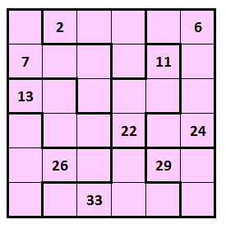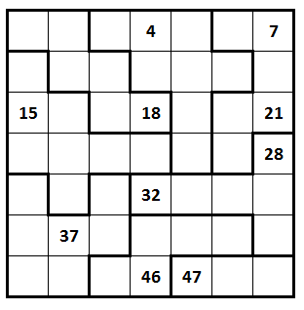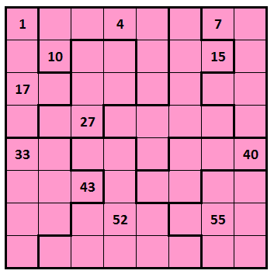
The real maths
1. How did you begin the puzzle? What strategies did you use? How do they compare with the strategies used by your partner and others?
2. Which of the puzzles was the easiest? Which was the most challenging? Why?
3. What do you notice about the positions of the numbers in the various grids? Try comparing the placement of the multiples of 2 in the largest and middle-sized puzzles.
What do you notice about the position of the multiples of 3? 4? 5? How do the positions of these numbers compare to the placement of numbers in a 10 x 10 grid? Can you identify any patterns or offer any conjectures you could test?
4. Which number clues in each jigsaw are not needed to solve the puzzle? Why?
5. What difference would it make if the number in any square was kept the same but was rotated 90 or 180 degrees? Ask your teacher if you’d like to try this extension challenge (a copy is available to teachers at Mr Dooley’s Maths Compendium) or create your own puzzle to share with a friend.
www.teachingprimarymaths.com – Resource #1008200414
Number Grid Jigsaws
by teachingprimarymaths.com
Activity Sheet B
Instructions:
1. Cut neatly along each of the bold black lines in the puzzles below to create 3 different jigsaw challenges for a partner. Your partner will cut out 3 different jigsaw puzzles for you.
2. Swap all of your puzzle pieces with those of your partner and try to reassemble the different number jigsaws.
3. Use your maths skills to analyse the puzzles and respond to the questions below.
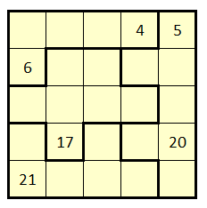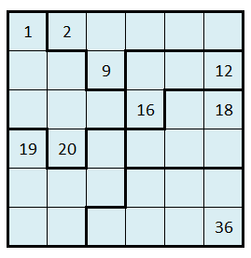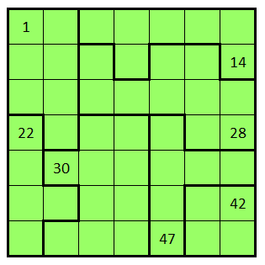
The real maths
1. How did you begin the puzzle? What strategies did you use? How do they compare with the strategies used by your partner and others?
2. Which of the puzzles was the easiest? Which was the most challenging? Why?
3. What do you notice about the positions of the numbers in the various grids? Try comparing the placement of the multiples of 2 in the largest and middle-sized puzzles.
What do you notice about the position of the multiples of 3? 4? 5? How do the positions of these numbers compare to the placement of numbers in a 10 x 10 grid? Can you identify any patterns or offer any conjectures you could test?
4. Which number clues in each jigsaw are not needed to solve the puzzle? Why?
5. What difference would it make if the number in any square was kept the same but was rotated 90 or 180 degrees? Ask your teacher if you’d like to try this extension challenge (a copy is available to teachers at Mr Dooley’s Maths Compendium) or create your own puzzle to share with a friend.

www.teachingprimarymaths.com – Resource #1008200414

Number Grid Jigsaws – TEACHING NOTES
by teachingprimarymaths.com
Implementation note for teachers:
Puzzles can be printed in colour or greyscale. The jigsaws have been created in different colours to enable students to determine which puzzle each piece belongs to once cut out. However, contrasting tones have also been used to ensure the puzzles remain distinguishable when more cost-effective greyscale printing is used. The numbers on Activity Sheet B are shown in bold so that students can discern between the two different sets.
Sample questions for discussion/analysis with students:

1. How did you begin the puzzle? What strategies did you use? How do they compare with the strategies used by your partner and others?
2. Which of the puzzles was the easiest? Which was the most challenging? Why?

3. What do you notice about the positions of the numbers in the various grids? Try comparing the placement of the multiples of 2 in the largest and middle-sized puzzles.
What do you notice about the position of the multiples of 3? 4? 5? How do the positions of these numbers compare to the placement of numbers in a 10 x 10 grid? Can you identify any patterns or offer any conjectures you could test?

4. Which number clues in each jigsaw are not needed to solve the puzzle? Why?

5. What difference would it make if the number in any square was kept the same but was rotated 90 or 180 degrees? Ask your teacher if you’d like to try this extension challenge (a copy is available to teachers at Mr Dooley’s Maths Compendium) or create your own puzzle to share with a friend.
Your teaching/facilitation notes:
www.teachingprimarymaths.com – Resource #1008200414

